

Training Day Handbook

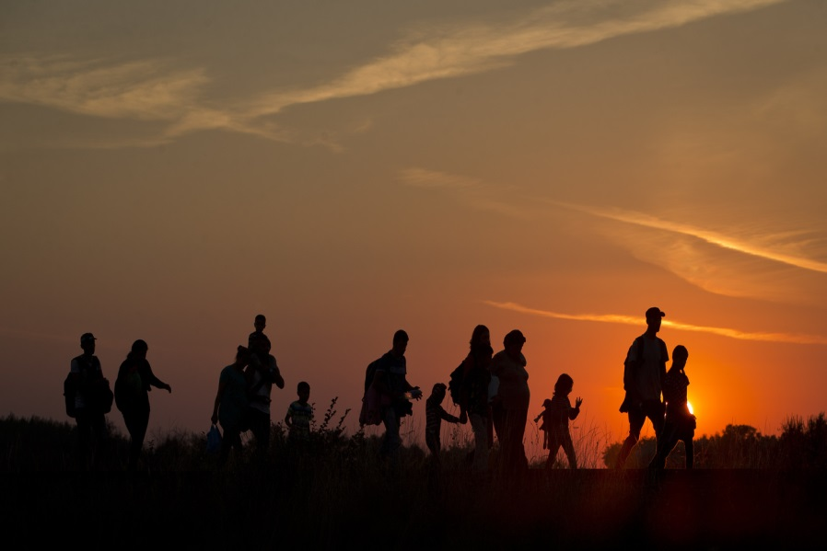

An introduction to the emotional health and wellbeing
needs of Unaccompanied Asylum Seeking Children.

Contents

Section page

Schedule 3

Overview 4

Methodology 5

A UASC story 6 – 8

Governance 9

Emotional health and well-being 10 – 13

Training slides 14 - 41

Schedule

9.30 – 9.40 Introduction and house keeping

9.40 – 10.15 Overview

10.15 – 11.15 UASC Story

11.15 – 12.15 Governance

12.15 – 1.00 Lunch and networking

1.00 – 1.15 Early Intervention Framework

1.15 – 2.15 Sleep

2.15 – 3.15 Hope

3.15 – 3.30 Tea

3.15 – 3.30 Fast Feet Forward

4.30 – 5.00 Close

- Overview

  - Background
Due to the current refugee crisis and increase in the volume of unaccompanied children arriving in the UK and seeking asylum there has been an identified need to develop a governance and early intervention framework from which quality of care in respect of emotional health and wellbeing interventions can be delivered. This work is pertinent to the whole of the UK due to the practice of dispersal of these children to other geographical localities.

UNICEF states:

The refugee and migrant crisis in Europe – whether off its coasts, on its shores, or along its roadsides – is a crisis for children.

One in every four asylum seekers in Europe so far this year has been a child. A total of 110,000 children sought asylum between January and July 2015 – an average of over 18,000 children every month in Europe. As a project looking at emotional health and wellbeing the needs, protection and best interests of each one of these children should always come first. It is a matter that touches our deepest principles of humanity and responsibility. Children are victims of humanitarian crises – they are not the cause of them.

The displacement of minors is part of a Europe-wide crisis that provokes extreme political and emotive reactions, as is illustrated by the recent reversal of the German ‘open door’ policy and can be witnessed through monitoring the vocabulary of the British press. There is a widespread confusion of attitudes and knowledge of what is possible. This is compounded by a conflation of the notion of ‘immigration’ which is perhaps the most inflammatory topic in current British politics, with the terrible reality of what it means to be a refugee and an asylum seeker.

The political volatility of this crisis cannot be disregarded but there is a moral and humanitarian obligation to look urgently past the rhetoric and to the reality of a situation that is occurring right now. The health needs of this vulnerable group of children require further research, the devising of operational strategies and a national and a Europe-wide response.

This training day will focus on the emotional health and wellbeing component of the UASC health project in Kent. The things the project have been able to learn in respect of vulnerabilities that compromise resilience and the intervention protocols they have developed and evidenced as effective clinical practice.

- Methodology
2.1 A participatory action inquiry
Action inquiry is a step by step methodology, in which the investigators(s) plan, act, observe and reflect. It is humanistic as it looks to work and collaborates with those involved and affected to explore the emergent meaning and understanding under observation. In observing the effect of our actions at each stage of the cycle from which change emerges, we were looking to build a scaffolding of knowledge which allowed us to continuously incorporate findings into subsequent stages of the investigation.
As already stated the project team, staff at reception centres, social workers and UASC are all within the observations and actions taking place. Therefore all those involved, affected and connected are an active part of the team and relational in nature. Bjorn (1996) and Shotter (1998) refer to participatory action inquiry as multi-dimensional, dialogical and a fluid form of self-development.
What the project found is that the action inquiry steps were a mirror to the process being undertaken in interventions being developed. These interventions were responsive to the needs identified with UASC in reception centres and the community and link to Shotters ideas that everything is related to everything else.
Alex Ntung who has experience of being a UASC described what he called the ‘steps’ to success and his story has informed the interventions being observed, for further detail. Therefore in developing an understanding of what is needed, we shaped interlinked step’s from which responses were collaboratively made and UASC are supported with new understanding formed from a practical relational responsiveness to the stories they tell.
Zoe Given-Wilson, a Child Psychologist Researcher at the Centre for the Study of Emotion and Law states that there are a number of barriers to the way professionals hear the stories a UASC is telling which have an effect on their asylum outcomes. It is the same in the talk about emotional health and wellbeing in that the assumption made, the interview style, the lack of trust when yet another professional is asking questions are likely barriers in what is heard as well as what is understood. To avoid these barriers, the project workers were based in close proximity to the reception centres and became known to the boys, as well as staff. This enabled them to hear the different voices and to be curious about the stories told and the reason for the telling.

2.2 The Journey we make; a UASC story:
Alex Ntung came to the UK as an UASC in 1997; he shared his story with newly arrived UASC at one of the reception centres.
2.3 Instructions:
- In groups of 3 or 4 take 20 minutes to read Alex story and then discuss the impact the story has on you.
- Jot down any ideas you may have (in the empty column), about what Alex is describing and how it connects to his emotional health and wellbeing in respect of the metaphors he is using and the beliefs he is sharing.

Alex Monologue: | Your response:
We are similar; you and I have shared situations, journeys, loss.

We have escaped with one beginning journey to a journeys end,
Just to start all over again.

So it is a beginning again and the journey is hard and long, similar and yet different.

This new journey is made step by step, it has many paths from which more loss can come.

And yet there are steps that take you to
your dreams and hopes;

The dream of belonging, of safety, of freedom to be;

The dream that my kin will be safe and free.

In the beginning; at the start of the first journey, I turned to run from the massacre.
To escape the torture,
To run into your arms of safety.
And at that journeys end I was left naked of tongue, or knowing how to be,
I was left alone because of the fear in your eyes that spoke of my loss.

So I arrived, to start the journey again;
I arrived to a new place, a new culture and the socio vertigo that made me dizzy
It put me into a spin.

I heard the stories that made the fear in your eyes,

I climbed the steps that made the fear go away.

I proved the lies of your fear to be untrue.

Each step a milestone; each step a victory.

Your lie said I would not speak, so I dived deep into your sounds and found I could make them.

Your lie said I would always take from you, so I learnt how I could earn and give you back more than you have given.

Your lie said that I would hurt you, so I learnt how to bring peace through a kaleidoscope of knowledge made up of the journeys, of BA’s and MA’s and the socio vertigo that I now understand and can translate.

Each step is a challenge; and the challenge is not the end of the world, it will change.

The challenge is never as bad as what you have seen and what could be;
In the moments of anger and fear, of not knowing, there are hands holding you, wishing you well.

Don’t forget that you bring with you amazing things;

The stories our grandparents told us;
Our culture,
Our way of being community.
People here like to know these things and it is a way we can contribute and give what is ours.

When I came and started this journey, I shared my music and the music made people look at me without fear and we became friends.

The music is now something we share and celebrate together, it is us and our community, and we have all been changed.

What the home office decides, it does, what it does.

Yet in every other way you are in control;
So follow the steps, my steps, the steps of success, and the steps of doing and being your dreams.

I am a leader,
I am making a difference,
I am changing things.

My story is shared and told and retold – it honours my loss;

Yet my loss is never gone, it is in my breath, in my eyes, in my steps.

I am in a place of safety and I can achieve.

Today is not my worst day;

Today I am held and I hold you by sharing my steps to success.

- Governance
  - Professional competencies
The system(s) around UASC is complex and diverse. Each agency and professional is governed by Article 22 of the UNCRC and works towards a child’s best interest in the processes and decisions being undertaken. Yet each has a different role and relationship with the child which can at times be problematic. There are also statutory rights that come into play, which can be challenging due to capacity and resource constraints. Each agency has its own governance structures which don’t overlap and therefore an agreement in respect of what each understands from each other in respect of a UASC’s emotional health and wellbeing has been developed, so that clinical excellence and capacity issues are regulated.
New competencies were devised to support each agency to manage the proficiencies of staff in their delivery of emotional health and wellbeing interventions. The competencies supported a management structure to become embedded within agencies, where staff knew their competency levels and could refer onwards if the child required something beyond their know-how.

  - Where do you fit?
See the following link to access the animation that depicts the competencies and how to use them: https://www.youtube.com/watch?v=PffoAYMrCtA

  - Who should support?

Read the following story(s) about Isam and discuss in groups of 4 which level of support you think is required and why.

- Emotional Health &Wellbeing

  - Themes
Several themes emerged in the conversations which were used as a point from which interventions were made.
Those being:
- Disordered sleep patterns
- Refeeding symptoms
- Loss of hope
- Trauma symptoms

  - Early Intervention Framework
The project looked at a resilience model of care in which interventions became a form of inoculation from which the child’s resilience could be protected. To enable this to take place an early intervention framework was devised, trialed and significant shifts were seen in reported symptoms.
  - Disordered sleep patterns
The sleep work is a 3 pronged protocol which encompassed social education through a sleep hygiene presentation, a sleep pack that supported the physical dysregulation such as hypervigilance to be managed. The 3^{rd.} intervention was a body clock reversal prescription that supported a slow and incremental change to a nocturnal sleep pattern.
When this work was audited, there was a 92% reduction in symptoms; young people were requesting sleep packs as were staff. This protocol has enabled young people with disordered sleep patterns to be identified; have a measured improvement in their symptoms and staff who are working with UASC are aware of this as a symptom of the Journey made.
See powerpoint slides at the back of the handbook for further information.

  - Refeeding Symptoms
It is know that when UASC first arrive in the UK they ate very little and seemed to struggle to manage food due to semi-starvation as they travel through Europe.
In the clinic sessions that took place in the reception centres with a GP many of the UASC complained of the semi-starvation symptoms. Often the young people would be wearing warm clothing on a hot day and would complain of gastro-intestinal discomfort. Some were symptomatic with headaches and most of all they complained of disturbed sleep which also is linked to the noctornal pattern of sleep used on the journey.
There is therefore a need to consider the effect of the semi-starvation aspect of the journey, as self-harm actions, anxiety and a loss of direction for the future are something that is being exibited in some of the behaviours of UASC.
See slides at the back of this handbook for additional information as to the protocol that has been deviced and should be followed if you are working with a UASC who is experiencing these symptoms.

  - Hope as a driver towards the future:
Therapeutic work with unaccompanied asylum seeking children (UASC) is often seen as difficult because there is often no back story from which to understand their skills and abilities. They are disadvantaged by trauma, by cultural isolation which creates socio vertigo, by a loss of formal education and language from which they can express themselves and the relational isolation that comes from arriving in the UK alone. On arrival they struggle to articulate hopes for the future, their hopes being realised in reaching the UK. They don’t know what is possible and have often been told stories of a promised land, which doesn’t materialise in the way they imagined. So how do we talk about hope? Hope in this instance being a driver towards a certain type of future, the energy behind actions that forms and shapes possibilities.

The future is going to happen with or without aspirations, with or without family re-unification, with or without asylum being granted. Each moment is a movement towards something, so what can we hope for as professionals and how does what we do make a difference to the future and all its potential? We want to share some of our experiences of working with UASC in Kent. In our work, other professionals involved and connected to an individual child often ask us to support the child to move on from the trauma they have experiences and the associated losses along the way to enable them to start to function towards assimilation. As a nation we make judgements about ‘good’ and ‘bad’ outcomes and feel the child has failed which by association calls into question what we have done and what we have achieved together. We talk about these children being not in education, employment or training (NEET) yet seemingly motivated and aspirational. We need to consider what the blocks are and how it is we can support a little bit of dreaming to take place.

In a therapeutic environment the child can often be in a dilemma as to what to talk about, who to talk about and what the effects of talking might be. They may have beliefs about what they need to say to receive asylum and this may prohibit other stories to be told. There therefore a dilemma when those involved in the conversation have different wishes or needs about whether or not to talk. This dilemma is in the relationship between the ‘stories lived and stories told’ (Pearce & Pearce, 1998). There is a dilemma for everyone involved, the young person, the corporate parent, staff involved in the child’s care and the therapist supporting the system. The corporate parents in the need to protect, provide, support and manage the variant needs of the child. There are also members of staff who perceive distress, who hear as yet untold stories and develop a relational closeness with the child. Coupled with this, there are educators and other providers who are involved and connected to the child. At times there are therapeutic dilemmas as a prioritising of the child’s needs take place. How I formulate and support emergent priorities from an emotional health and wellbeing perspective needs to hold in mind the other competing dilemmas. We also need to be mindful to support the system to give a coherent account of situated abilities to form the best possible outcomes for the child. This way of working is the concept of hope as dynamic action.

When we formulate a multiplicity of hope in language and there are agreed actions within the system towards those hopes, we are likely to form a dynamic relational interaction from which things can emerge. Explicit disclosures or an acknowledgement of trauma does not tell the whole story. As professionals, we can underestimate the need not to talk, to avoid, to act and form stories which are about wellness and being in a place of safety. One of the worries is that talking about what has been can create too much reality, a reality that a UASC does not want to re-live or re-experience. So we need to consider which voice do we privilege at each point and what it is we are creating for each other in the actions we take.

Recently we met with a UASC who had been asleep for the first 72 hours of arrival to the UK, had exhibited a high level of distress which was causing reception staff concern. In our assessment of him, we looked at family stories of pride and as the narrative unfolded about the massacre of his parents and sister. A key aspect of his story was education at a boarding school and the meaning this was given by his parents in who he could be and what he should become. From an emotional health and wellbeing perspective, we wanted to link this person into continuing bonds that would support his ability to process the traumas he had experienced. Our formulation linked to the virtual school agenda, which was to support and facilitate education to take place. Yet the corporate parent wanted to move the child to a county where he would be more likely to receive foster care, a key indicator of positive protectors for the child. Each had the best interest of the child in mind, yet there were competing agendas which needed to be understood and explored together. There was an impasse in what it was that was happening and conversations needed to take place to support an understanding to emerge from which actions were taken and needs met.

This example shows that there can be a dichotomy of needs: a need to be in living routines of the past, and yet a need to recognise the emergent needs in the here and now. When as a system we find ourselves in this type of impasse, we often privilege one person’s need rather than work with the dilemma in a way that enables both the past routine and the current emergent necessities talk to happen.

See slides at the back of the handbook for transcripts and further information in the use of this protocol.

4.6: Trauma
The DSM-IV-TR (American Psychiatric Assessment, 2001) defines trauma as a traumatic event that requires that person to have experienced, witnessed, or be confronted with an event or events that involve actual or threatened death or serious injury, or threat to physical integrity of self or others and that the person’s response involves intense fear, helplessness or horror.
This definition aligns with the reported experiences of Unaccompanied Asylum Seeking Children (UASC). It is not surprising then that as a cohort, such children have a higher incidence of post-traumatic stress disorder (PTSD) than the general population. It is recognised that they have significant trauma, triangulated by the original need to flee their home of origin, the physical migration journey, and the immigration process once they reach safety. For UASC, the immigration process is ongoing and a constant source of distress, as they attempt to navigate a sea of information and due to the risk that they may be refused leave to stay. Therefore, the risk for developing PTSD is known and there is a need to think about early intervention strategies, in that there is a need to immunise and protect a UASC from developing PTSD (Bronstein & Montgomery, 2013; Heide et al, 2014).
See slides at the end of the handbook for the Fast Feet Forward protocol and evidence base.

- Training day slides
5.1 Re-feeding symptoms
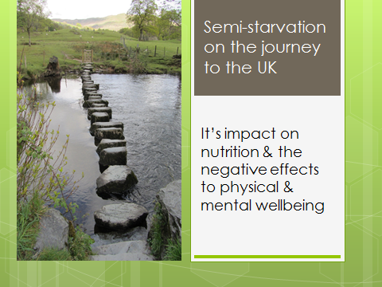

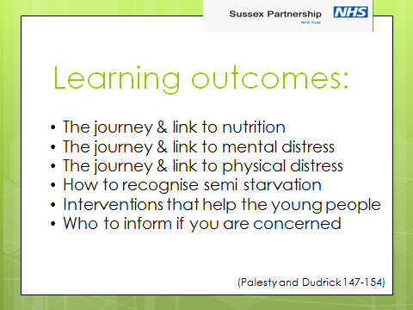

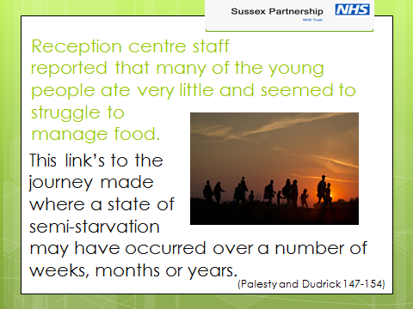

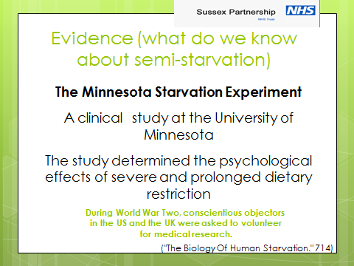

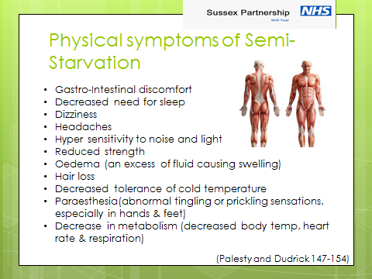

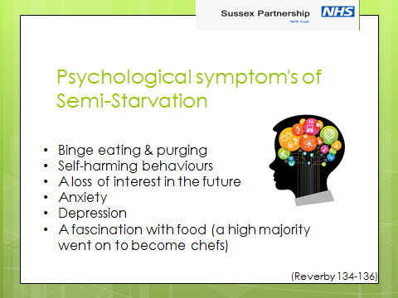

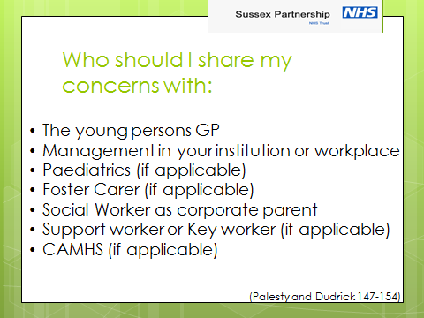

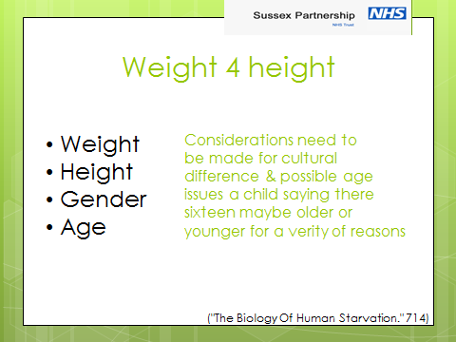

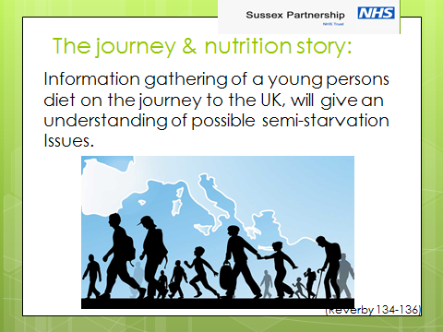



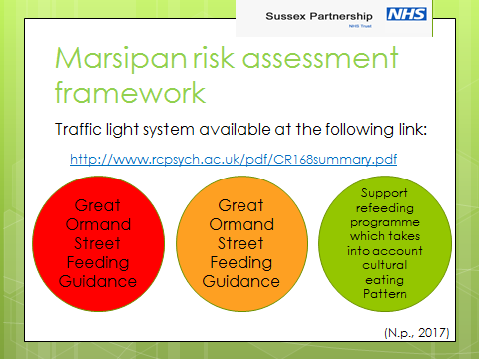

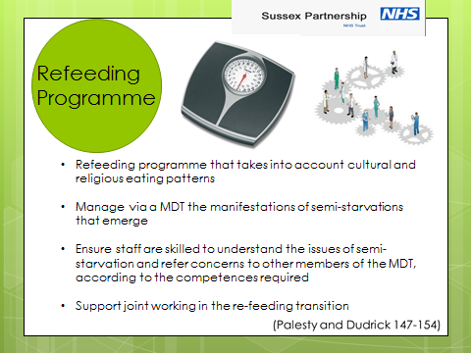

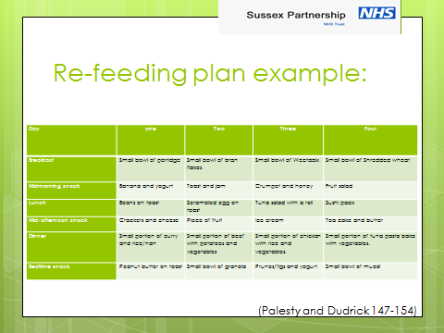

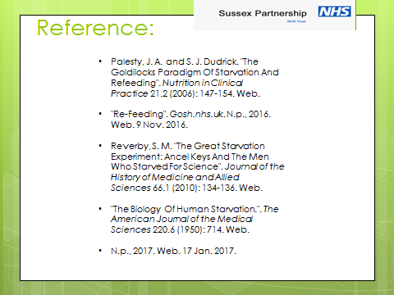

5.2 Hope

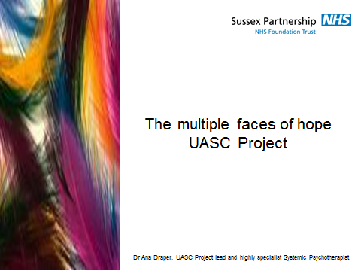

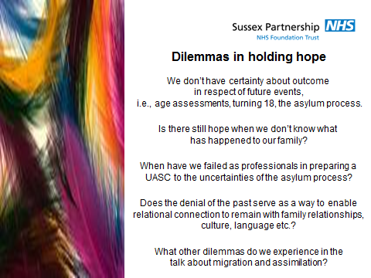

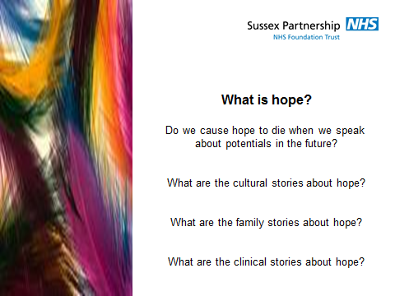

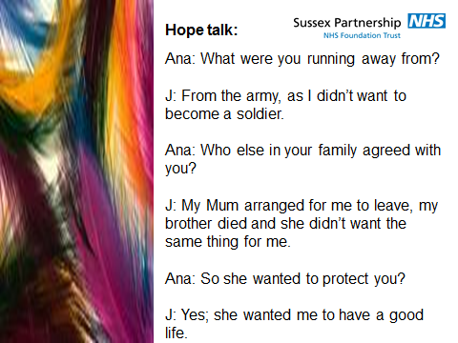

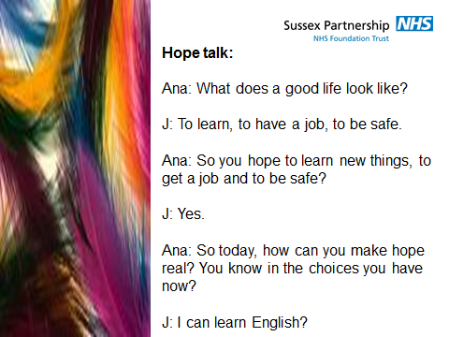

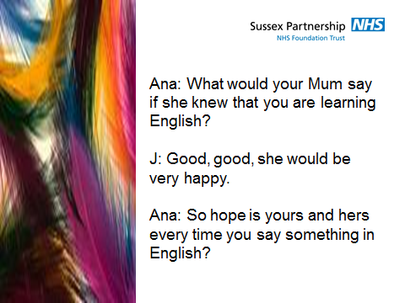

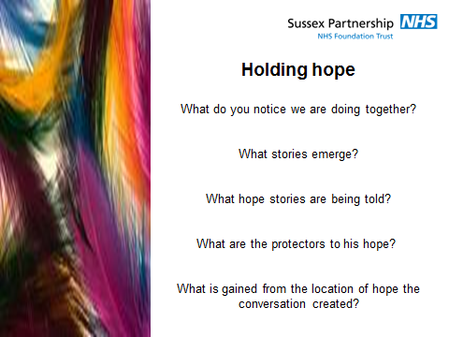

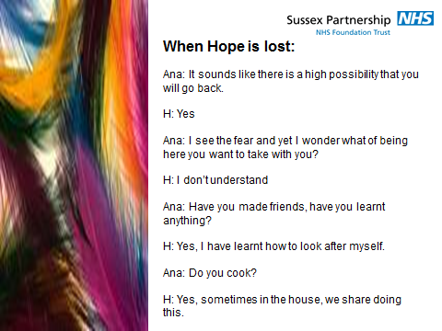

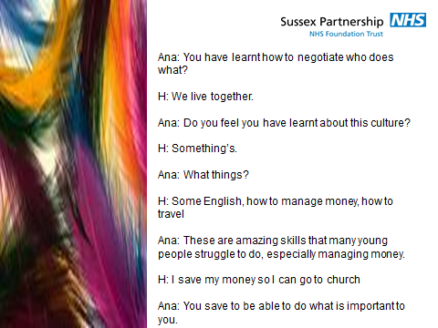

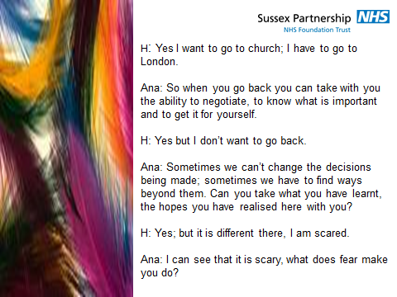

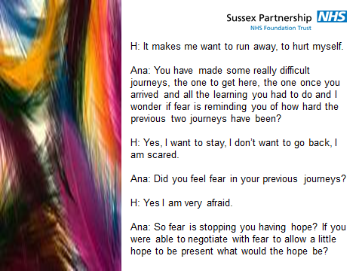

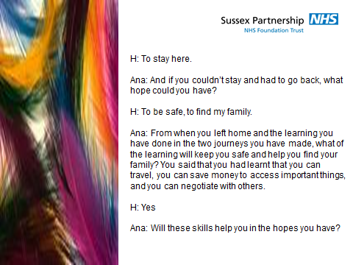

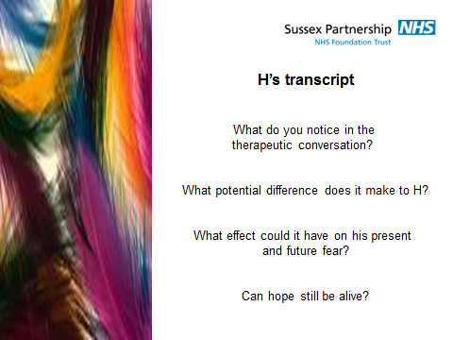

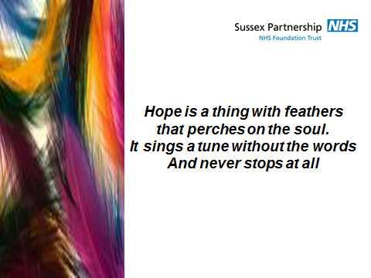

5.3 Trauma
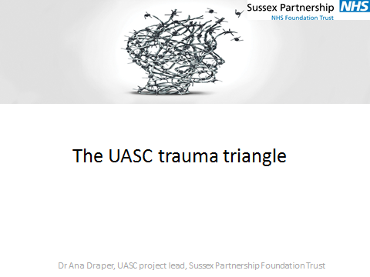

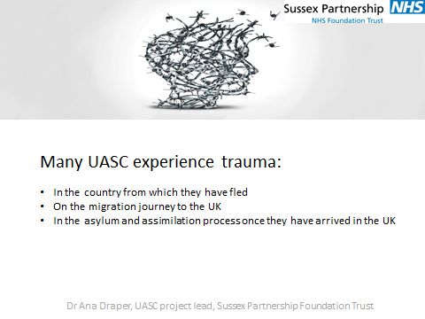

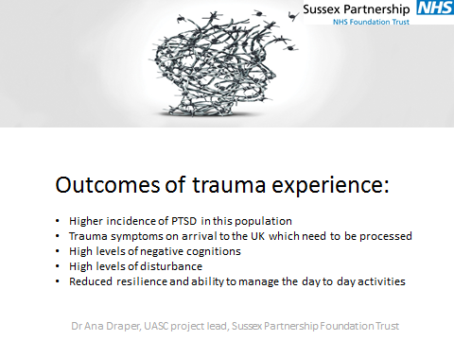

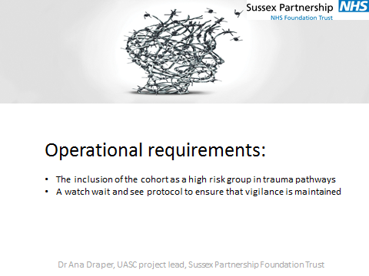

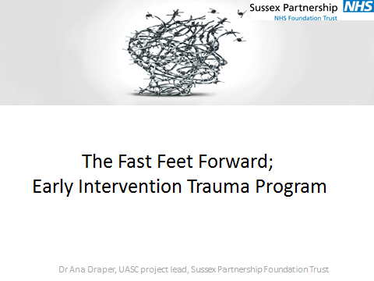

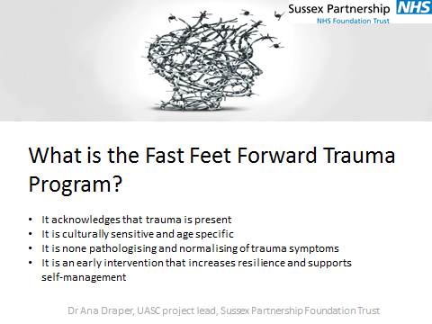

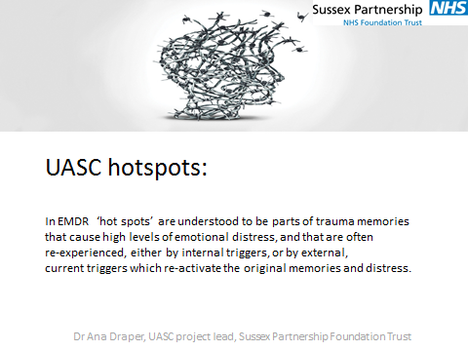

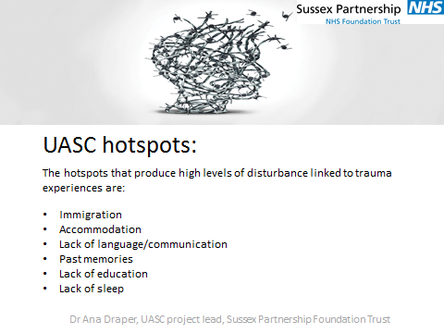

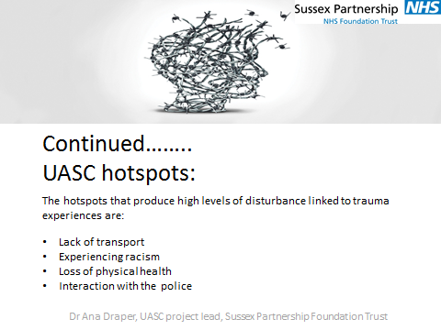

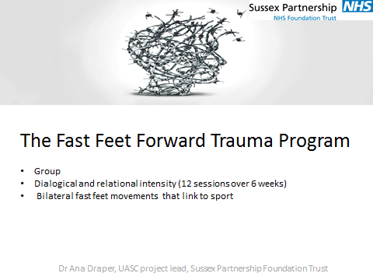

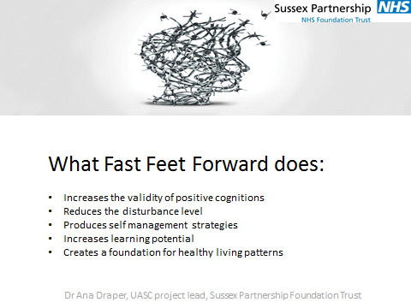

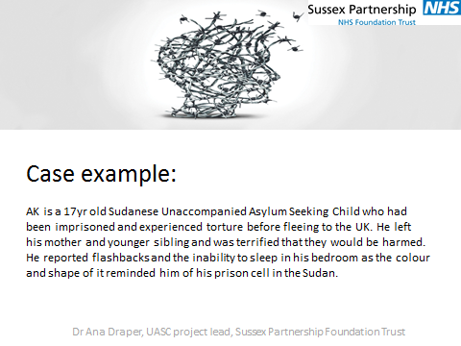

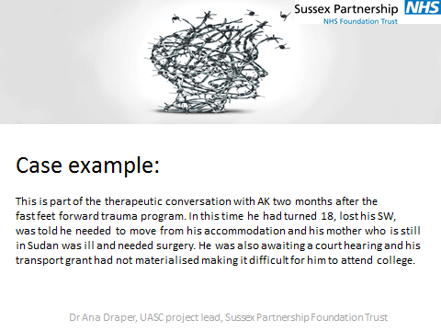

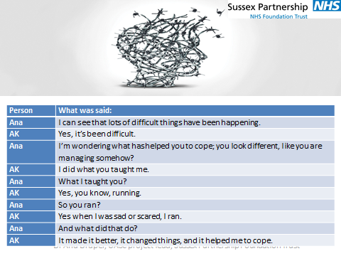

5.4 Sleep

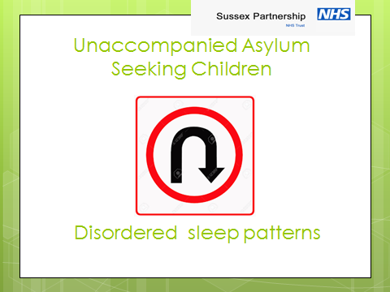

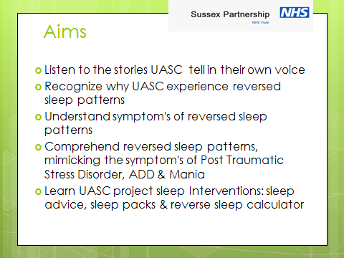

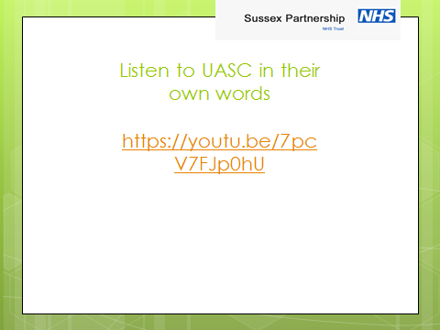

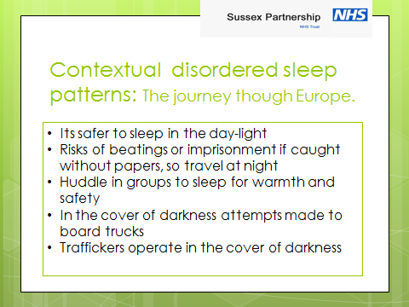

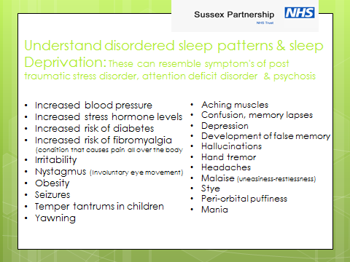

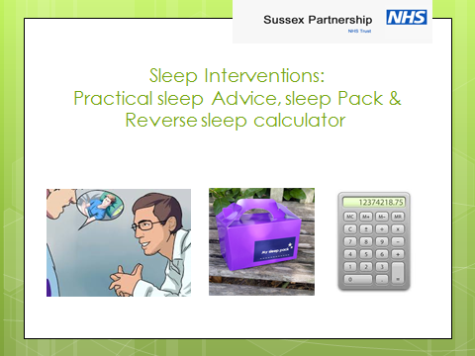

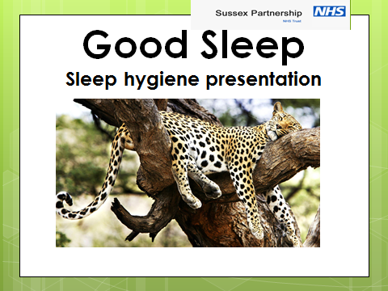

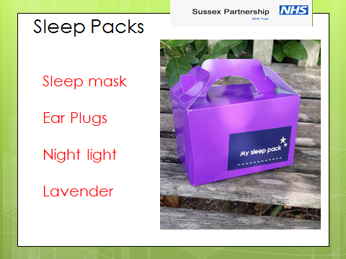

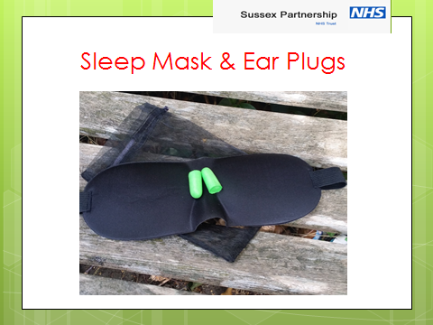

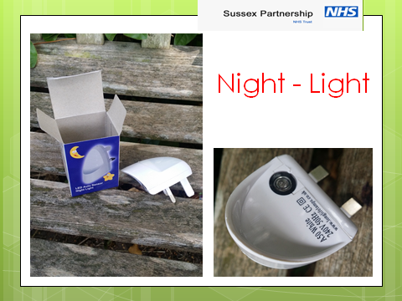

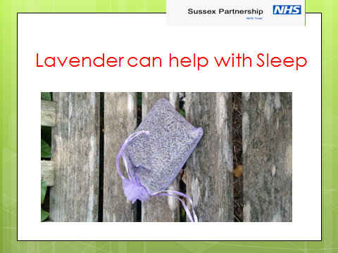

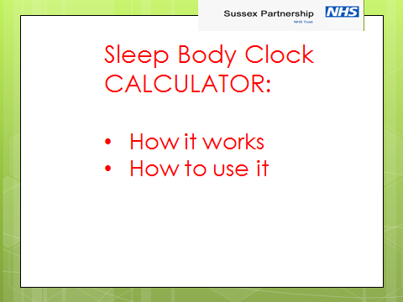

Björn Gustavsen (1996) Development and the social sciences: an uneasy relationship. In Toulmin, S, and Gustavsen, B. (Eds.) Beyond Theory: Changing Organizations through Participation. Amsterdam and Philidephia: John Benjamins
Shotter, J; (1998), Participatory Action Research in a New Age of Distributed Learning and multidimensional dialogically discursively structured flexible, decentralised, heterachical, fluid forms of self-developing organizations. Work Organization and Europe as a Development Coalition, Brussels, Jan 28th, 1998
Pearce, W.B. & Pearce, K.A. (1998) Transcendent story telling: Abilities for systemic practitioners and their clients. Human Systems, Vol 9, issues 3-4.

